
Writing your Post-16 Personal Statement

NAME:___________________________________________________

Remember that your personal statement will give a very important first impression to staff at the Post-16 Centres and to possible future employers. It is really important that it is well written and paints an accurate and positive picture of you and your strengths.

Aim for approximately one side of A4, written in word, font size 12, Times New Roman. Ask parents/carers, friends to check your final version for spelling, grammar and punctuation.

Your personal statement must be completed by Wednesday 21st October. It should be written in word and then copy and pasted into the personal statement section of your MyChoice@16 profile. It is important that you don’t write your personal statement straight into MyChoice@16 as there is no spell check facility.

Use the headings below as a guide for what to include in each paragraph:

- Why would you like to continue in education?
What subjects have you enjoyed at school and might like to continue? If you know what course(s) you would like continue with then say what interests you about them (you will need to read up on it!). Be enthusiastic about what you currently study and what you would like to study after Y11.

- Character
What are you like? Quiet, loud, introvert, extrovert, lively, fun-loving, enjoy working with others/on your own. How do your friends describe you? Trustworthy, a good listener, honest, dependable.

- Attitude to work and People
What are you like at school? Hard-working, organised, work well under pressure.
What subjects do you like and why (can say what topics/aspects you particularly like, give examples)?

- Interests
What are your main interests: sports teams, keep fit, hobbies, socialising - how have/do these help you
What extra-curricular activities do you do? They could involve some of the following: Sports team, extra classes like dance/art class, interests and enrichment activities.

- Responsibilities - in school and outside
Write out your experiences and responsibilities. What have you gained from them? For example – preparing an assembly - communication skills, trust, and independence.
Other responsibilities could include Prefect duties, drama/musical productions, charity work, coaching, looking after siblings etc.

- Jobs/Work Experience/Volunteer work
Have you ever done something that was paid/unpaid work? What were your main responsibilities? What skills did you develop? Communication, speaking to customers/public, working independently, computer skills, team work, managing others, working to deadlines; problem solving and using your initiative

- Ambitions and future plans
Write out what you would like to do in the future - next couple of years as well as a career (mention here if you hope to go to University/straight in to work)
Also add the ambitions you would like to fulfil in the coming years like traveling, bungee jump etc.
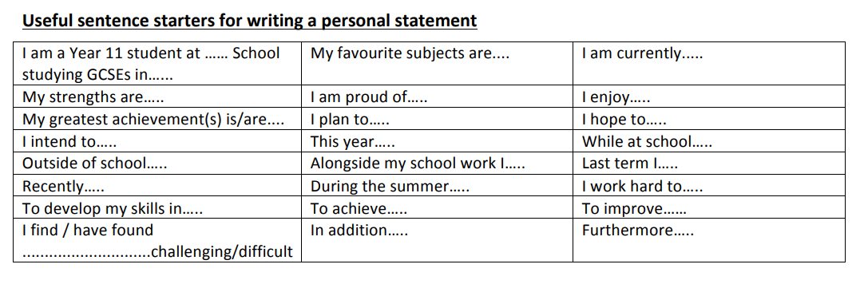

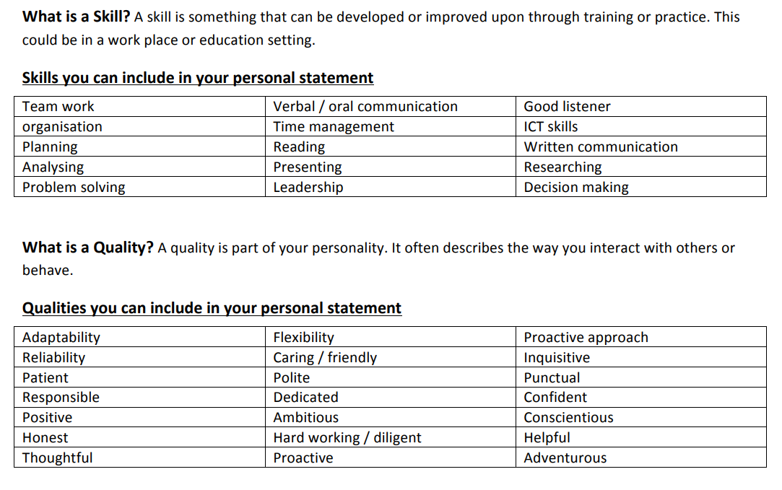
For further help:
https://www.ucas.com/further-education/post-16-qualifications/post-16-options/how-write-personal-statement-further-education
PARAGRAPH 1: Why would you like to continue in education?
What subjects have you enjoyed at school and might like to continue? If you know what course(s) you would like continue with, mention these and then say what interests you about them (you will need to read up on it!). Be enthusiastic about what you currently study and what you would like to study after Y11
Bullet point your thoughts/ideas here

Write your draft to then type up here (you do not have to use all the lines!):

PARAGRAPH 2: Character
What are you like? Quiet, loud, introvert, extrovert, lively, fun-loving, enjoy working with others/on your own. How do your friends describe you? Trustworthy, a good listener, honest, dependable.
Bullet point your thoughts/ideas here

Write your draft to then type up here (you do not have to use all the lines!):

PARAGRAPH 3: Attitude to work and People
What are you like at school? E.g. Hard-working, organised, work well under pressure.
What subjects do you like and why (can say what topics/aspects you particularly like, give examples)?
Bullet point your thoughts/ideas here

Write your draft to then type up here (you do not have to use all the lines!):

PARAGRAPH 4: Interests
What are your main interests: sports teams, keep fit, hobbies, socialising - how have/do these help you
What extra-curricular activities do you do? They could involve some of the following: Sports team, extra classes like dance/art class, interests and enrichment activities.
Bullet point your thoughts/ideas here

Write your draft to then type up here (you do not have to use all the lines!):

PARAGRAPH 5: Responsibilities - in school and outside
Write out your experiences and responsibilities. What have you gained from them? For example – preparing an assembly - communication skills, trust, and independence.
Other responsibilities could include Prefect duties, drama/musical productions, charity work, coaching, looking after siblings etc.
Bullet point your thoughts/ideas here

Write your draft to then type up here (you do not have to use all the lines!):

PARAGRAPH 6: Jobs/Work Experience/Volunteer work
Have you ever done something that was paid/unpaid work? What were your main responsibilities? What skills did you develop? Communication, speaking to customers/public, working independently, computer skills, team work, managing others, working to deadlines; problem solving and using your initiative
Bullet point your thoughts/ideas here

Write your draft to then type up here (you do not have to use all the lines!):

PARAGRAPH 7: Ambitions and future plans
Write out what you would like to do in the future - next couple of years as well as a career (mention here if you hope to go to University/straight in to work)
Also add the ambitions you would like to fulfil in the coming years like traveling, bungee jump etc.
Bullet point your thoughts/ideas here

Write your draft to then type up here (you do not have to use all the lines!):

